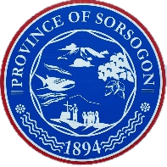Republic of the Philippines

Province of Sorsogon

OFFICE OF THE PROVINCIAL GOVERNOR

Capitol Compound, Brgy. Burabod, East District, Sorsogon City – 4700

**ACCOMPLISHMENT REPORT**

**For the month of June 15 – 30, 2021**

NAME OF EMPLOYEE : **Richard P. Gigantone**

NAME OF OFFICE : **Governor’s Office**

ASSIGNMENT : **ICTD**

**ACTUAL WORK:**

1. Development of back-end for Inventory Management System.

|  |  |  |
| --- | --- | --- |
| **TASK / Designation** | **QTY** | **ACCOMPLISHMENT** |
| Computer Programmer |  | Maintenance of the following functionalities or modules   * Purchase Request Management |
|  | Development of API routes for the following components:   * Purchase Order CRUD * Request Management |

**Prepared by:**

**Richard P. Gigantone**

**Noted:**

**CARMELO H. GRIARTE**

IT OFFICER / ICT